Ex.No: 18

HIGH LEVEL LANGUAGE EXTENSION WITH CURSORS

Aim:
To implement Cursors using program in MySQL.
Problem- 1
Write a Cursor program using MySQL to retrieve the email-ids(build an email list) of employees from employees table.

SOLUTION :
create table employees(id integer, Name varchar(100), email varchar(100));
insert into employees(id, Name, email) values(1, "Harry Potter", "pharry@warnerbros.com");
insert into employees(id, Name, email) values(2, "Clark Kent","kclark@dccomics.com");
insert into employees(id, Name, email) values(3, "Tony Stark", "stony@marvel.com");

DELIMITER $$
CREATE PROCEDURE build_email_list (INOUT email_listvarchar(4000))

BEGIN

DECLARE v_finished INTEGER DEFAULT 0;
DECLARE v_emailvarchar(100) DEFAULT "";

-- declare cursor for employee email

DECLAREemail_cursor CURSOR FOR

SELECT email FROM employees;

-- declare NOT FOUND handler

DECLARE CONTINUE HANDLER FOR
NOT FOUND SET v_finished = 1;

OPEN email_cursor;
get_email: LOOP

FETCH email_cursor INTO v_email;
IF v_finished = 1 THEN
LEAVE get_email;

END IF;
-- build email list
SET email_list = CONCAT(v_email,";",email_list);

END LOOP get_email;
CLOSE email_cursor;

END$$
DELIMITER ;

-- Calling the procedure and getting the email list

SET @email_list = "";
CALL build_email_list(@email_list);

SELECT @email_list;

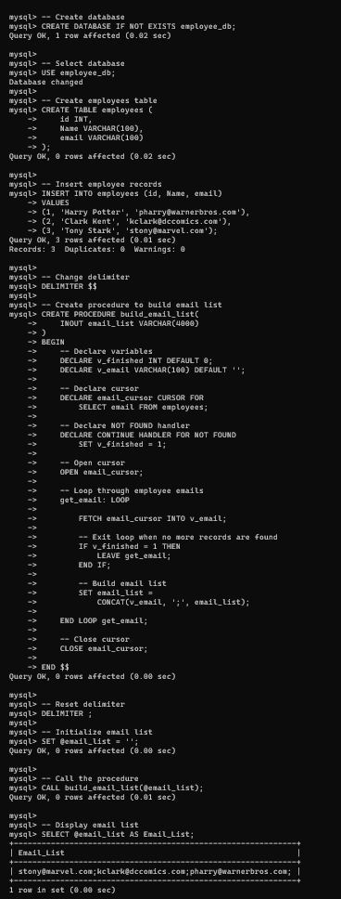

RESULT:
Thus the Cursor program using MySQL is executed successfully.

